**Quiz Lesson 04.docx must be done before you do this program!**

**Start every program with the skeleton:**

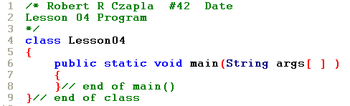

**After you type in the skeleton – compile and correct any syntax errors. When typing in statements, do one section at a time – compile and correct any syntax errors.**

